Cause and Effect Graph Testing Technique

Cause-Effect Graph graphically shows the connection between a given outcome and all issues that manipulate the outcome. Cause Effect Graph is a black box testing technique. It is also known as Ishikawa diagram because of the way it looks, invented by Kaoru Ishikawa or fish bone diagram.

It is generally uses for hardware testing but now adapted to software testing, usually tests external behavior of a system. It is a testing technique that aids in choosing test cases that logically relate Causes (inputs) to Effects (outputs) to produce test cases.

A “Cause” stands for a separate input condition that fetches about an internal change in the system. An “Effect” represents an output condition, a system transformation or a state resulting from a combination of causes.  
   
[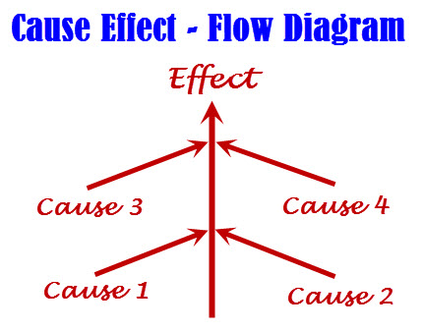](http://www.softwaretestingclass.com/wp-content/uploads/2014/01/cause-effect-flow-diagram.jpg)

The Cause-Effect Diagram can be used under these Circumstances:

* To determine the current problem so that right decision can be taken very fast.
* To narrate the connections of the system with the factors affecting a particular process or effect.
* To recognize the probable root causes, the cause for a exact effect, problem, or outcome.

**Benefits of making cause-Effect Diagram**

* It finds out the areas where data is collected for additional study.
* It motivates team contribution and uses the team data of the process.
* Uses synchronize and easy to read format to diagram cause-and-effect relationships.
* Point out probable reasons of difference in a process.
* It enhances facts of the procedure by helping everyone to learn more about the factors at work and how they relate.
* It assists us to decide the root reasons of a problem or quality using a structured approach.

**Steps to proceed on Cause-Effect Diagram:**

**Firstly:**Recognize and describe the input conditions (causes) and actions (effect)

**Secondly:** Build up a cause-effect graph

**Third:**Convert cause-effect graph into a decision table

**Fourth:**Convert decision table rules to test cases. Each column of the decision table represents a test case

**Symbols used in Cause-effect graphs:**

[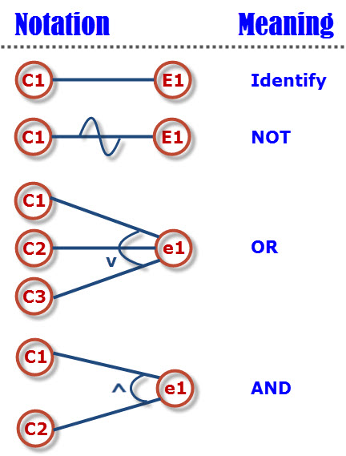](http://www.softwaretestingclass.com/wp-content/uploads/2014/01/cause-effect-notation-meaning.jpg)

VIT Organizes an international Conference in September 2015, to publish papers in the conference some amount has been fixed as the registration fees. Students from VIT and other colleges have to register with Rs.250 and 300 respectively; Staff from VIT and other colleges has to register with Rs.400 and 500 respectively; Industrialist from india have to register with Rs.1000 and abroad with 50$; Research Scholars will pay Rs.750 as their fees. Early bird registration is only for VIT Students and Staff they can avail 10% discount if they register with in august 15th 2015. Draw cause and Effect Graph for the above scenario and derive the effective test cases for the same